2023-24 Lincoln Highway Heritage Corridor Mini-Grant Application
Lincoln Highway Heritage Corridor
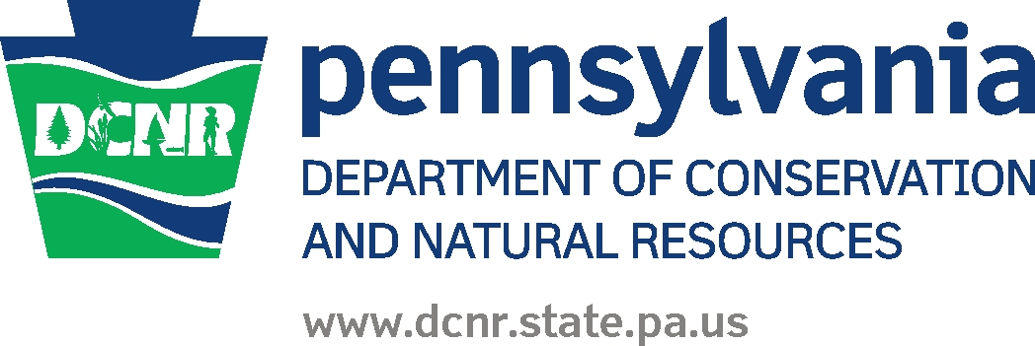3435 State Route 30 East Latrobe, PA 15650
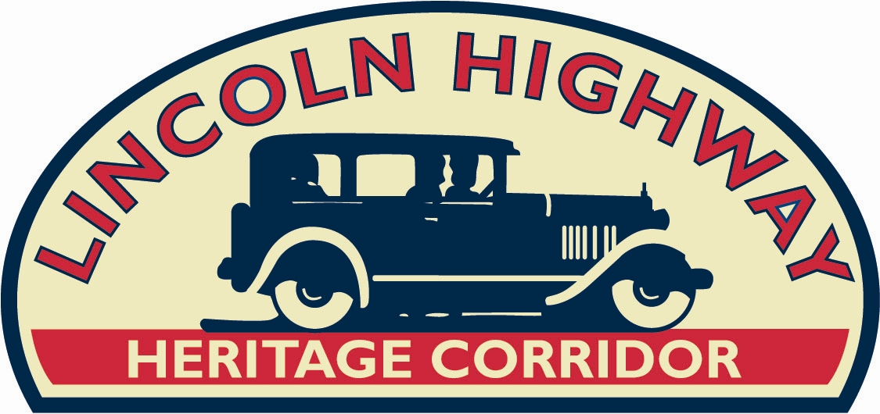
Application must be typed; handwritten will not be accepted. Five copies of your application, with one copy of each required attachment, must be received in LHHC office by 4 pm on Tuesday, August 1, 2023.

1. Application Information:
Organization or Municipality____________________________________________________
Grant Contact Name and Title __________________________________________________
Address ____________________________________________________________________
City _____________________________________ Pennsylvania Zip__________________
Phone _____________________ Email_____________________

2. Project Information:
Project Title_________________________________________________________________
Project Address – Exact Address ________________________________________________
Municipality________________________________County_______________________
MINI-GRANT REQUEST: $__________ TOTAL PROJECT AMOUNT: $___________
Status of Cash Match-Yes, we have the cash match on hand___. No, I am still raising it___.

3. Circle those that apply to your project: The 2023-24 focus for this Mini-Grant Opportunity is
either:
Conservation or Education or Preservation

4. Project Scope: Using 12 pt. font, type a full separate page describing your Scope of
Work/Project. It should address the need, the final product/deliverable, and a complete project description. Include enough information for the reviewer who is not familiar with your project or your organization. Also include a timeline, beginning with the Award Letter from the Lincoln Highway Heritage Corridor, and continuing with specific milestones of the project until the project end date, which should be no later than 15 months from the Notice to Proceed letter. Be mindful of seasonal weather if your project requires work outdoors.

5. Project Budget: By completing this full mini-grant application, you are affirming that you have the cash match required (1:1) for your grant request of $__________. Attach a typed (12 pt. font) full project budget (which should include source of match money and the amounts) to this application. If your total project cost exceeds the mini-grant request and cash match, provide details on other costs, and how they will be funded in your full project budget.
(These mini-grant funds cannot be used to fulfill match requirements for other DCNR-funded projects or for any of your own administration/staff costs.) You cannot begin your project (not any part of it) until receipt of a Notice to Proceed Letter from the Lincoln Highway Heritage Corridor.

6. Partnerships: If your project involves other nonprofit organizations or municipalities, please list those here with contact name and phone.

Org./Muni. Contact Phone

7. Required attachments: If a nonprofit organization, one copy of your 501(c)(3) IRS determination, and one copy of your current Certificate from the PA Dept. of State, Bureau of Charitable Organizations. Only applications with the required attachments will be reviewed and ranked.

8. Required Signatures (2). If a nonprofit organization, the Executive Director must sign this application, as well as the Board President. If a municipality is the applicant, then the department head who is applying, as well as the Borough Manager (or Township Supervisor) must also sign and date.

__________________________________________ ________________________
Executive Director or Municipal Dept. Head Date

__________________________________________ _________________________
Board President or Borough Mgr./Twp. Supervisor Date

+++
Selection Criteria: Projects will be ranked by a 5-person committee (Lincoln Highway Heritage Corridor Executive Director, three Lincoln Highway Heritage Corridor board members, and the DCNR Liaison) on criteria listed below with the following weighted points which total 100.
Review your application to ensure you are addressing each of the following points:

- 30 pts. - must demonstrate how the public will be served if you receive funding;
- 30 pts. – must demonstrate how your project aligns with the mission and goals of the LHHC;
- 30 pts. - must demonstrate how your organization/municipality will promote the Lincoln
Highway and the Lincoln Highway Heritage Corridor;
- 10 pts. – followed all directions, including requested attachments.

Process and Documentation:

- The full application, along with required attachments, must be received in the LHHC office by 4 p.m., Tuesday, August 1, 2023.
- Award notification letters will be mailed on or about September 1, 2023. Letters will also be mailed out to those projects not selected.
- A Partnership Agreement between LHHC and the sub-grantee will need to be approved by DCNR, then executed. No work on this project can begin until this point. Any cash match spent before that is not considered eligible as cash match.
- One-half the mini-grant award will then be issued along with the Notice to Proceed letter.
- The second payment (40%) will be released upon request and need, based on bi-annual progress reports (which will need to show proof of expenditures – copies of both sides of checks along with matching invoice – and progress made).
- The applicant must ‘front’ the final 10% of the project and submit a satisfactory closeout report that reflects satisfied expenditures of the final 10%, at which point the LHHC will submit all to DCNR in Harrisburg for their approval. When DCNR releases the final 10% to the LHHC, the LHHC will then release the final 10% to you, the Mini-Grant Recipient. Questions? Call the LHHC at 724-879-4241 and ask for Kim Cady.

